
SHIRE HIGHLANDS EDUCATION DIVISION
2026 MALAWI SCHOOL CERTIFICATE OF EDUCATION MOCK
EXAMINATION

COMPUTER STUDIES
Subject Number: M039/II
Time Allowed: 2h 30min sessions
8:00 am onwards
Tuesday, 10 March

PAPER II
(50 marks)

- This paper contains 4 printed pages. Please check.
- This paper has three questions. Answer all questions.
- All questions should be answered using a computer. After completing each question, print your work. Save the answers in a removable disk to be submitted together with the printed copy.
- After saving your work in the removable disk, delete any work that you may have saved in the computer. Failure to follow this instruction may lead to other candidates copying your work and this may lead to disqualification.
- Write your Full Name at the top of each page of the answer sheet used on the removable disk.
- At the of the paper, submit all your answer sheet and the removable disk used to the invigilator.

© 2026 SHED
- a. Create a database called VOTERS REGISTER and save it in removable disk. (2 marks)
b. Design a table named ‘MY CENTRE’ in the database using the fields in table 1
(2 marks)
c. Enter the following records into the MY CENTRE table. (4 marks)
Table 1 Datasheet

National ID | Full Name | Sex | Village | Voted
WZ005E | Amidu Favour | F | Ngoloma | Yes
HR45EX | Foloko Sammy | M | Mjojo | No
89V4BY | Mpunga Mercy | F | Ulongwe | Yes
717GCM | Khama Chokani | M | Duswa | No
NYVP5A | Zakata Fatima | F | Folopenzi | Yes

d. Set national ID as a primary key. (1 mark)
e. Add a field to the table and name it Age between Sex and Village and enter the following records 45,23,19,53 and 34 in that order respectively. (3 marks)
f. Design a query that displays Full Name, Sex, National ID, and Voted, showing all females who voted. (4 marks)
g. Create a columnar report using the Report Wizard from the table, excluding the Village field. (3 marks)
h. Save the report using your Examination Number as the file name. (1 mark)
i. Print the report on one page and submit it together with the removable disk. (1 mark)

- a. Create a spreadsheet named ‘Tentative Budget’ and save it in a removable disk.
(2 marks

b. In the spreadsheet file, enter the data as shown in table 2 below: (4 marks)
Table 2
 | A | B | C | D | E
1 | MONTHLY BUDGET
2 | Categories | January | February | March | April
3 | Groceries | 3340 | 1457 | 3200 | 2760
4 | Utilities | 1375 | 600 | 740 | 560
5 | Clothing | 1250 | 1530 | 2250 | 3460
6 | Gasoline | 870 | 960 | 450 | 578
7 | Airtime | 750 | 430 | 320 | 335
8 | Food | 6860 | 1600 | 3370 | 4345
9 | Total Expenditure
10 | Income | 11200 | 9500 | 15250 | 8590
11 | Remark

c. Using appropriate spreadsheet function, calculate the total expenditure for each month. (2 marks)
d. Using an appropriate IF function in cell B11, update the spreadsheet to display a remark indicating “deficit” if total expenditure is greater than income and “surplus” if total expenditure is less than income. (3 marks)
e. Replicate the formula to the rest of the months. (1 mark)
f. Insert a pie chart as object in new sheet showing all months and the total expenditure values. (3 marks
g. Insert a title on the pie chart and name it “Monthly Budget Summary”. (1 mark)
h. Display category name and percentage data labels on the pie chart. (1 mark)
i. Insert a right header and type your full name on the pie chart (2 marks)
j. Print the pie chart in landscape orientation. (1 mark

- a. Create a birthday card using desktop publisher named “Memorable Birthday” (2 marks)

b. Design the card as it appears below (2 marks)

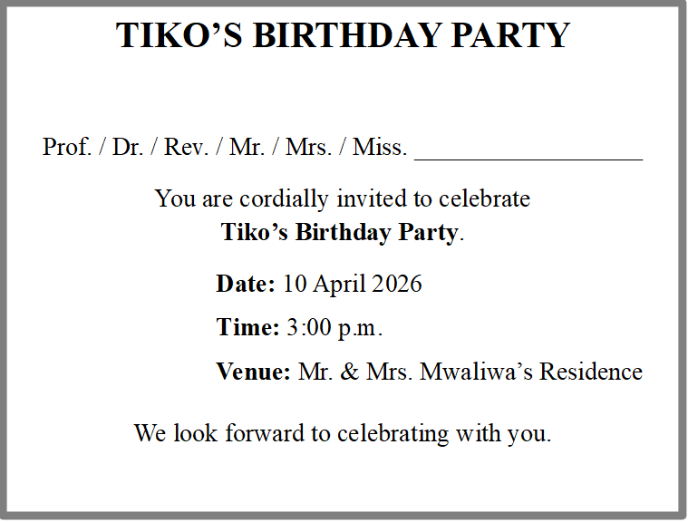

c. Draw a smiley face shape and place it at the top right of the card. (2 marks)
d. Change font type of the heading to Colonna MT and font size 28. (1 marks)
e. Insert a header and type your full name. (1 mark)
f. Apply balloon 3 colours boarder art to the whole publication. (1 mark)
g. Print the card and submit together with removable disk. (1 mark)

END OF QUESTION PAPER
NB. This paper contains 4 printed pages

